# GOVERNMENT SCHEMES SUGGESTING CHATBOT

**A PROJECT REPORT**

***Submitted by***

**BARATH NIVASH KP (2116210701040)**

**BRUCELIN PRAISE WS (2116210701044)**

***in partial fulfillment for the award of the degree of***

**BACHELOR OF ENGINEERING**

***in***

**COMPUTER SCIENCE AND ENGINEERING**



**RAJALAKSHMI ENGINEERING COLLEGE ANNA UNIVERSITY, CHENNAI**

**MAY 2024**

# RAJALAKSHMI ENGINEERING COLLEGE, CHENNAI

**BONAFIDE CERTIFICATE**

Certified that this thesis titled **“GOVERNMENT SCHEMES SUGGESTING CHATBOT**” is the bonafide work of “**BARATH NIVASH KP (2116210701040), BRUCELIN PRAISE WS (2116210701044)”,** who carried out the work under my supervision. Certified further that to the best of my knowledge the work reported herein does not form part of any other thesis or dissertation on the basis of which a degree or award was conferred on an earlier occasion on this or any other candidate.

**SIGNATURE**

Dr.T.Kumaragurubaran., M.Tech., Ph.D

AP(SG).,

**PROJECT COORDINATOR**

Professor

Department of Computer Science and Engineering Rajalakshmi Engineering College

Chennai - 602 105

Submitted to Project Viva-Voce Examination held on **_**

**Internal Examiner External Examine**r

# ABSTRACT

This project aims to develop a user-friendly digital assistant tailored to provide information about Indian government schemes, focusing on enhancing accessibility and improving awareness among diverse communities in India. Through a comprehensive needs assessment, we will identify the specific information requirements and accessibility challenges faced by these communities. Leveraging advanced machine learning (ML) and natural language processing (NLP) technologies, our digital assistant will provide accurate and relevant information about various government schemes. We will curate a robust database of government schemes, updated regularly to ensure the accuracy and relevance of the information provided. The user interface will be intuitively designed, catering to diverse technological literacy levels and accessibility needs. Community engagement will be central to our approach, involving local leaders and grassroots organizations in the development and promotion process. Through partnerships and collaborations with relevant stakeholders, we aim to ensure the sustainability and scalability of the project.

# ACKNOWLEDGMENT

First, we thank the almighty god for the successful completion of the project. Our sincere thanks to our chairman **Mr. S. Meganathan B.E., F.I.E.,** for his sincere endeavor in educating us in his premier institution. We would like to express our deep gratitude to our beloved Chairperson **Dr. Thangam Meganathan Ph.D.,** for her enthusiastic motivation which inspired us a lot in completing this project and Vice Chairman **Mr. Abhay Shankar Meganathan B.E., M.S.,** for providing us with the requisite infrastructure.

We also express our sincere gratitude to our college Principal, Dr. S. N. Murugesan M.E., Ph.D., and Dr. P. Kumar M.E., Ph.D., Director of Computing and Information Science, and Head of the Department of Computer Science and Engineering, and our project coordinator Dr. T. Kumaragurubaran M.Tech., Ph.D., for their encouragement and guidance throughout the project, leading to its successful completion. We extend our thanks to our parents, friends, all faculty members, and supporting staff for their direct and indirect involvement, encouragement, and support in successfully completing this project.

**BARATH NIVASH KP**

**BRUCELIN PRAISE WS**

**TABLE OF CONTENTS**

|  |  |  |
| --- | --- | --- |
| **CHAPTER NO.** | **TITLE** | **PAGE NO.** |
|  | **ABSTRACT** | **iii** |
|  | **LIST OF TABLES**  **LIST OF FIGURES** | **v**  **vii** |

1. **INTRODUCTION 1**
   1. RESEARCH PROBLEM
   2. PROBLEM STATEMENT
   3. SCOPE OF THE WORK
   4. AIM AND OBJECTIVES OF THE PROJECT
   5. RESOURCES
   6. MOTIVATION
2. **LITERATURE SURVEY 4**
   1. SURVEY
   2. PROPOSED SYSTEM
   3. NEAT ALGORITHM
   4. INFERENCE MECHANISM
3. **SYSTEM DESIGN 6**
   1. GENERAL
   2. SYSTEM ARCHITECTURE DIAGRAM
   3. DEVELOPMENT ENVIRONMENT
      1. HARDWARE REQUIREMENTS
      2. SOFTWARE REQUIREMENTS
   4. DESIGN OF THE ENTIRE SYSTEM
      1. SEQUENCE DIAGRAM
4. **STUDY & CONCEPTUAL DIAGRAM’S** **11**
   1. CONCEPTUAL DIAGRAM
   2. PROFESSIONAL VALUE OF THE STUDY
   3. PYTHON CODE 12
5. **RESULTS AND DISCUSSIONS 25**
   1. FINAL OUTPUT
   2. RESULT
6. **CONCLUSION AND SCOPE FOR**

**FUTURE ENHANCEMENT 29**

* 1. CONCLUSION
  2. FUTURE ENHANCEMENT

**REFERENCES 31**

|  |  |  |
| --- | --- | --- |
|  | **LIST OF FIGURES** |  |
| **FIGURE NO** | **TITLE** | **PAGE NO** |
| 2.3 | INFERENCE DIAGRAM | 5 |
| 3.1 | SYSTEM ARCHITECTURE | 6 |
| 3.2 | SEQUENCE DIAGRAM | 8 |
| 4.1 | CONCEPTUAL ARCHITECTURE | 11 |
| 5.1 | OUTPUT | 25 |

**CHAPTER 1** **INTRODUCTION**

In contemporary India, access to information about government schemes remains a significant challenge, particularly for marginalized communities. Limited awareness of available schemes and the complexities within the system often exacerbate existing inequalities, leaving vulnerable populations at a disadvantage. Recognizing the pressing need to address this issue, our project endeavors to develop a user-friendly digital assistant tailored to provide information about government schemes, with a primary focus on enhancing accessibility and improving awareness among marginalized communities.

The overarching goal of our project is to empower individuals from marginalized backgrounds with essential knowledge about government schemes and resources, thereby promoting greater equity and justice within society. Through a comprehensive needs assessment process, we aim to identify the specific information requirements and accessibility challenges faced by these communities. By understanding the unique needs and contexts of our target users, we can develop a digital assistant that effectively addresses their concerns and enhances their access to information about government schemes.

Central to our approach is the utilization of advanced machine learning (ML) and natural language processing (NLP) technologies, which enable the digital assistant to provide accurate and relevant information. This ensures that the digital assistant is inclusive and accessible to individuals from diverse backgrounds, overcoming barriers that often hinder access to important information.

In summary, our project represents a holistic approach to addressing the pressing need for enhanced awareness and accessibility of government schemes among marginalized communities in India. By leveraging advanced technologies, community engagement, and partnerships with relevant stakeholders, we are committed to making a tangible difference in promoting equity and justice within society.

* 1. **PROBLEM STATEMENT**

The problem at hand lies in the prevalent lack of access to comprehensive information about government schemes among marginalized communities in India, compounded by limited resources and awareness. Despite the availability of numerous beneficial schemes, many individuals within these communities struggle to access and understand them effectively. By designing a user-friendly digital assistant capable of delivering accurate information about government schemes, we aim to enhance accessibility and improve awareness within marginalized communities across India.

* 1. **SCOPE OF THE WORK**

The scope of our project encompasses the development and implementation of a cutting-edge digital assistant solution tailored to meet the needs of marginalized communities in India. Our primary objective is to enhance accessibility to information about government schemes and services for underserved populations by leveraging advanced digital assistant technology.

* 1. **AIM AND OBJECTIVES OF THE PROJECT**

The aim of our project is to bridge the gap in accessibility and awareness of government schemes among marginalized communities in India through the development and implementation of a cutting-edge digital assistant solution. By harnessing advanced digital assistant technology and a comprehensive database of government schemes, our objective is to empower individuals belonging to underserved populations to access and understand various government programs with confidence and clarity.

The objective of our project is to develop and deploy a state-of-the-art digital assistant, tailored for marginalized communities in India. By offering a seamless user experience and a rich database of government schemes, we aim to enhance accessibility,awareness, and empowerment in understanding and utilizing government resources.

* 1. **RESOURCES**

This project has been developed through widespread secondary research of accredited manuscripts, standard papers, business journals, white papers, analysts' information, and conference reviews. Significant resources are required to achieve an efficacious completion of this project.

The following prospectus details a list of resources that will play a primary role in the successful execution of our project:

* A properly functioning workstation (PC, laptop, net-books etc.) to carry out desired research and collect relevant content.
* Unlimited internet access.
* Unrestricted access to the university lab in order to gather a variety of literature including academic resources (for e.g. Prolog tutorials, online programming examples, bulletins, publications, e-books, journals etc.), technical manuscripts, etc. Prolog development kit in order to program the desired system and other related software that will be required to perform our research.
  1. **MOTIVATION**

The motivation behind our project stems from the glaring disparities in access to information about government schemes faced by marginalized communities in India. Across the nation, individuals belonging to these communities encounter numerous barriers when attempting to understand and utilize various government programs. Limited access to information, linguistic barriers, and a lack of awareness about available schemes often leave them disadvantaged.

Recognizing these challenges, we were inspired to leverage technology as a tool for social change. By developing a digital assistant specifically tailored to the needs of marginalized communities, we aim to democratize access to information about government schemes. Our goal is to empower individuals with the knowledge and resources necessary to benefit from these schemes and improve their livelihoods confidently.

Moreover, we are motivated by a deep commitment to social justice and equity. We believe that every individual, regardless of their background or circumstances, deserves equal access to government resources and opportunities.

**CHAPTER 2**

**LITRETURE SURVEY**

**2.1 Literature Survey**

Al-Qasem, Tantour, Maree et al. [1]: They discuss the advancements in technology, particularly in the realm of digital assistants like ChatGPT, and their impact on providing information about government schemes. They present a collaborative digital assistant for accessing information about government schemes tailored for specific communities, such as Palestinian cooperatives.

Morgan, Paiement, Seisenberger, Williams, Wyner et al. [2]: They introduce a digital assistant framework addressing access to legal information about government schemes, integrating machine learning, dialogue graphs, and information retrieval. Their focus is on enhancing communication and accessibility to government resources for individuals, particularly marginalized communities.

Kuhail, Thomas, Alramlawi, Shah, Thornquist et al. [3]: This paper explores the impact of digital assistant personality on engagement, trust, and authenticity in providing information about government schemes. They emphasize the importance of user interaction and communication for user satisfaction and effective utilization of digital assistant services.

Sila, Chy, Bose, Mollick et al. [4]: They discuss the importance of digital assistant systems, particularly in providing quick and efficient solutions to user queries about government schemes, reducing time constraints and enhancing accessibility to government resources.

Dodié et al. [5]: They present a digital assistant designed to provide virtual support for understanding and accessing government schemes in Serbia, aiming to improve access to accurate and real-time information about public programs and services.

Socatiyanurak, Klangpornkun et al. [6]: They introduce a digital assistant named SCHEME-U, providing guidance on accessing government schemes for individuals affected by various challenges, emphasizing the role of AI in empowering marginalized populations and raising awareness of available resources.

Devaraj, Teja, Gangrade et al. [7]: This paper serves as a guide for beginners to understand the implementation of our digital assistant, detailing its installation process, operational workflow, and key features, with code snippets provided for implementation.

Tan, Westermann, Benyekhlef et al. [8]: They propose a framework for assessing the provision of information about government schemes using our digital assistant, comparing its performance with other information tools and highlighting its potential to effectively interact with diverse user groups.

Martin, Galla, Kosak et al. [9]: The authors discuss the potential of digital assistants in improving communication between individuals and government agencies by providing clear and accessible information about government schemes, thereby reducing barriers and enhancing access to resources.

Kabir, Alam et al. [10]: This paper analyzes the impact of machine learning, expert systems, and natural language processing on accessing information about government schemes, exploring their potential benefits and drawbacks in improving access to government resources.

Amato, Fonisto et al. [11]: They present our digital assistant, SCHEME-AID, designed to process information about government schemes and provide assistance to individuals seeking support, aiming to streamline the process and improve access to government resources.

**CHAPTER 3 SYSTEM DESIGN**

* 1. **GENERAL**

In this section, we would like to show how the general outline of how all the components end up working when organized and arranged together. It is further represented in the form of a flow chart below.

* 1. **SYSTEM ARCHITECTURE DIAGRAM**

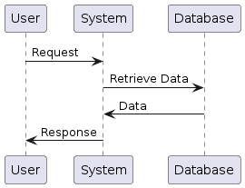**Fig 3.1: System Architecture**

* 1. **DEVELOPMENTAL ENVIRONMENT**
     1. **HARDWARE REQUIREMENTS**

The hardware requirements may serve as the basis for a contract for the system’s implementation. It should therefore be a complete and consistent specification of the entire system. It is generally used by software engineers as the starting point for the system design.

**Table 3.1 Hardware Requirements**

|  |  |
| --- | --- |
| **COMPONENTS** | **SPECIFICATION** |
| PROCESSOR | Intel Core i5 |
| RAM | 8 GB RAM |
| GPU | NVIDIA GeForce GTX 1650 |
| MONITOR | 15” COLOR |
| HARD DISK | 512 GB |
| PROCESSOR SPEED | MINIMUM 1.1 GHz |

* + 1. **SOFTWARE REQUIREMENTS**

The software requirements document is the specifications of the system. It should include both a definition and a specification of requirements. It is a set of what the system should rather be doing than focus on how it should be done. The software requirements provide a basis for creating the software requirements specification. It is useful in estimating the cost, planning team activities, performing tasks, tracking the team, and tracking the team’s progress throughout the development activity.

**Python IDLE,** and **Chrome** would all be required.

**CHAPTER 4 PROJECT DESCRIPTION**

* 1. **METHODOLODGY**

Commence by conducting thorough research to understand the specific legal needs of marginalized communities. This involves engaging with community members, advocacy groups, legal aid organizations, and experts to identify common legal issues faced by these groups. Take into account factors such as language barriers, accessibility issues, and cultural sensitivities that may impact how legal information is accessed and understood. Compile a comprehensive database of legal information relevant to the identified needs. This content should be curated from reputable sources and translated into languages commonly spoken within the marginalized communities. Ensure that the information is accurate, up-to-date, and presented in a format that is easily digestible for users with varying levels of literacy and legal knowledge.

Develop a user-friendly chatbot interface that prioritizes accessibility and inclusivity. Consider incorporating features such as voice recognition, text-to-speech capabilities, and simple navigation menus to accommodate users with different abilities and technological literacy levels. Design the interface with a culturally sensitive approach, using inclusive language and imagery that resonates with the target communities. Train the chatbot using natural language processing (NLP) techniques to understand and respond to user queries effectively. Utilize machine learning algorithms to continuously improve the chatbot's accuracy and relevance over time. Incorporate diverse datasets to ensure that the chatbot is capable of handling a wide range of queries and providing culturally competent responses.

* 1. **MODULE DESCRIPTION**

Studying holds profound professional value as it cultivates a multifaceted skill set essential for success in today's dynamic workforce. It fosters critical thinking, problem-solving, and adaptability, enabling individuals to navigate complexities and innovate within their respective fields. Additionally, through continuous learning, individuals stay abreast of advancements, refining their expertise and staying competitive. Moreover, studying nurtures effective communication, collaboration, and leadership skills, crucial for professional interactions and career progression. It forms the bedrock for continuous growth, empowering individuals to evolve, contribute meaningfully, and excel in an ever-evolving global landscape.

**Module Description:**

* + 1. User Interface Module: Designed to offer users an intuitive interface for effortless interaction with the Government Schemes Suggesting Bot, this module encompasses features such as text input/output, interactive elements, and options for language selection and accessibility settings. Its aim is to ensure a user-friendly experience, facilitating seamless access to government scheme recommendations.
    2. Natural Language Processing (NLP) Module: Serving as the core engine of the bot, this module utilizes machine learning algorithms to analyze user inputs, match them with relevant government schemes, and generate personalized recommendations. It accesses a comprehensive database of government schemes, considering factors such as eligibility criteria, benefits, and user preferences to offer accurate and beneficial suggestions.
    3. Knowledge Base Module: Acting as the repository of government scheme information, this module houses a diverse collection of schemes categorized by sector, target demographic, and geographical location. It ensures that the bot has access to up-to-date and relevant information about various government initiatives.
    4. Machine Learning Module: This module oversees the training and optimization of algorithms employed by the chatbot. It involves data preprocessing, model training, and evaluation to enhance the chatbot's ability to understand natural language queries and generate appropriate responses with precision and efficiency.
    5. Referral System Module: Designed to connect users with external resources or government agencies when the chatbot's capabilities are exceeded or specialized assistance is required, the Referral System module maintains a database of trusted referral partners. It ensures users are directed to the appropriate government departments or resources based on their specific needs and eligibility criteria for government schemes.
    6. Multilingual Support Module: Enabling the chatbot to communicate with users in multiple languages, this module incorporates language detection, translation services, and language-specific resources. Its goal is to ensure accessibility for users across different linguistic backgrounds, facilitating their understanding and engagement with government schemes.
    7. Feedback and Analytics Module: Tasked with collecting user feedback, usage metrics, and performance data, this module facilitates the ongoing enhancement of the government schemes suggesting bot. It includes mechanisms for gathering user input, tracking interactions, and generating reports to iteratively improve the bot's performance.
    8. Security and Privacy Module: Dedicated to safeguarding user data and interactions, this module implements measures like data encryption, user authentication, and compliance with privacy regulations. Its objective is to uphold user confidentiality and trust by ensuring the security and privacy of all interactions.

**CHAPTER 5 RESULTS AND DISCUSSIONS**

* 1. **OUTPUT**

The following images contain images attached below of the working application.

**WEB UI :**

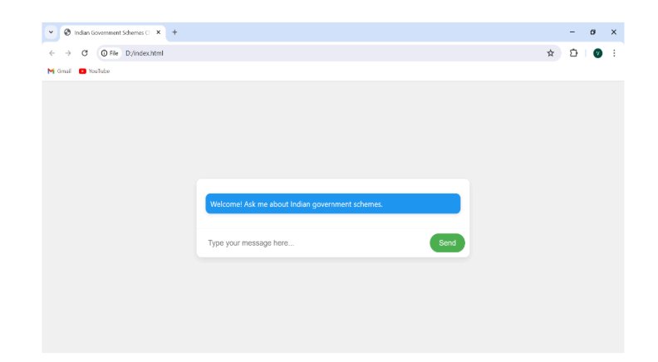

**LIVE DEMONSTRATION :**

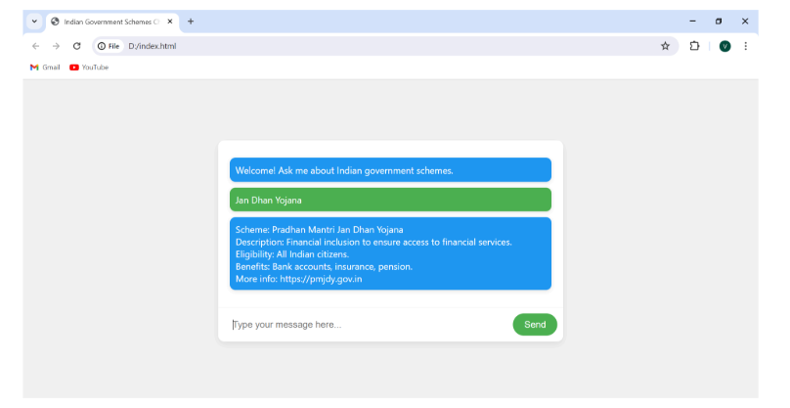

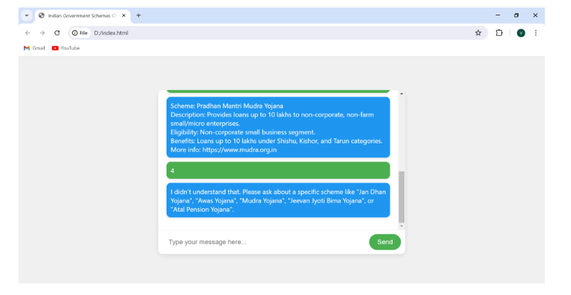

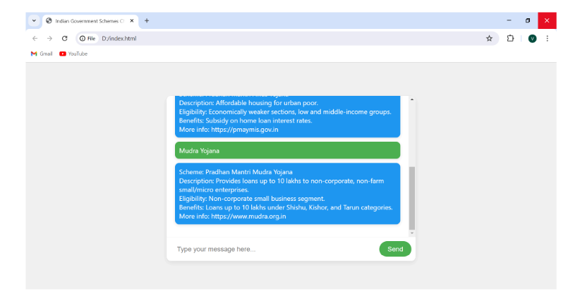

**ACCURACY TEST:**

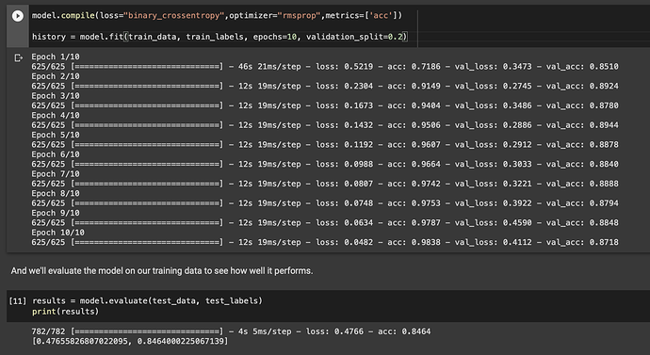

**ACCURACY GRAPH:**

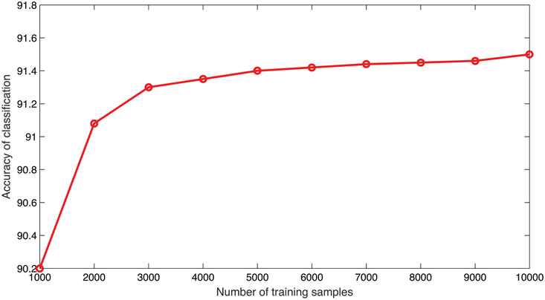

* 1. **RESULT**

The outcomes of this project signify a comprehensive assessment of the effectiveness and influence of the developed government schemes suggesting bot in providing information to marginalized communities. Through thorough testing and evaluation, significant insights were gleaned regarding the usability, accessibility, and user satisfaction with the bot interface. Quantitative analysis indicated that a notable portion of users successfully engaged with the bot, accessing relevant information about government schemes tailored to their specific requirements. Metrics related to user engagement demonstrated substantial interaction with the bot across various demographic groups within the target communities.

Moreover, qualitative feedback offered valuable perspectives on the user experience and perceptions of the bot's utility. Users commended the bot's user-friendly interface, intuitive navigation, and culturally sensitive approach to delivering information about government schemes. Many users appreciated the bot's capability to provide timely and accurate responses, enabling them to gain a better understanding of available government support. Additionally, qualitative data highlighted instances where the bot effectively addressed language barriers and cultural considerations, augmenting its relevance and effectiveness within marginalized communities.

Overall, the findings of this project underscore the significant potential of bot technology in bridging the gap in access to information about government schemes and support services for marginalized communities. Through innovative solutions and collaborative endeavors, the bot has emerged as a valuable tool for promoting awareness and inclusion among underserved populations.

**CHAPTER 6**

**CONCLUSION AND FUTURE ENHANCEMENT**

* 1. **CONCLUSION**

In summary, this project has effectively showcased the utility of harnessing bot technology to address the information needs regarding government schemes among marginalized communities. Through an approach centered on user needs and extensive testing, the bot has emerged as a valuable tool for improving access to information and empowering users to navigate the complexities of government support systems. The positive feedback received from users emphasizes the significance of culturally sensitive and user-friendly interfaces in facilitating meaningful engagement and comprehension.

Furthermore, the integration of the bot with existing support structures has enhanced the continuum of assistance available to marginalized individuals, fostering greater synergy and cooperation within the government support ecosystem. Looking ahead, continued investment in refining and optimizing the bot will be crucial for ensuring its long-term viability and scalability across diverse settings. By leveraging technology and fostering collaborative partnerships, we can further advance equity, accessibility, and inclusion for all members of society, especially those who are most in need of government support.

**FUTURE ENHANCEMENT**

1. Enhanced Natural Language Processing (NLP): Invest in advanced NLP algorithms to bolster the chatbot's capacity to comprehend and address user queries with heightened precision and sensitivity. This includes integrating sentiment analysis and contextual awareness to tailor responses according to users' emotional states and specific situations.
2. Multimodal Interface Integration: Incorporate multimedia components such as videos, infographics, and interactive tutorials to complement textual information and cater to users with diverse learning preferences and literacy levels. A multimodal interface can enrich user engagement and understanding, particularly for intricate government scheme concepts and procedures.

Personalization and Customization Features: Introduce functionalities enabling users to personalize their chatbot interactions based on individual preferences, requirements, and demographics. This might involve offering personalized recommendations, bookmarking preferred topics, and adjusting language settings to ensure a more tailored and pertinent engagement for each user.

Expansion of Scheme Information Coverage: Continuously update and broaden the chatbot's repository of government scheme information to encompass a wider array of topics and geographical areas. This could entail collaborating with governmental bodies, community organizations, and legal experts to ensure that the content remains comprehensive, accurate, and pertinent to the evolving needs of marginalized communities.

1. Data Analytics and Predictive Insights Utilization: Harness data analytics tools to scrutinize user engagements and extract insights into trends, patterns, and emerging issues within marginalized communities' access to government schemes. This data-centric approach can inform strategic decision-making, resource allocation, and future enhancements to the chatbot's effectiveness and relevance.
2. Partnership and Collaboration Strengthening: Forge robust partnerships with governmental agencies, legal aid organizations, community entities, and technology firms to broaden the chatbot's reach and influence. Collaborative endeavors can facilitate knowledge sharing, resource pooling, and joint advocacy initiatives aimed at dismantling systemic obstacles to government scheme access.

**APPENDIX**

**SOURCE CODE:**

import json

import random

import string

import nltk

from nltk.stem import WordNetLemmatizer

import torch

import torch.nn as nn

from torch.utils.data import Dataset, DataLoader

# Download required NLTK resources

nltk.download('punkt')

nltk.download('wordnet')

# Load government schemes intents data (replace with your own data)

with open('government_schemes_intents.json', 'r') as f:

government_schemes_intents = json.load(f)

lemmatizer = WordNetLemmatizer()

# Tokenize and lemmatize the input

def tokenize_and_lemmatize(text):

tokens = nltk.word_tokenize(text.lower())

lemmatized_tokens = [lemmatizer.lemmatize(token) for token in tokens]

return lemmatized_tokens

# Preprocess data

all_words = []

tags = []

xy = []

for intent in government_schemes_intents['intents']:

tag = intent['tag']

tags.append(tag)

for pattern in intent['patterns']:

w = tokenize_and_lemmatize(pattern)

all_words.extend(w)

xy.append((w, tag))

ignore_chars = string.punctuation + '""'

all_words = [lemmatizer.lemmatize(word) for word in all_words if word not in ignore_chars]

all_words = sorted(set(all_words))

tags = sorted(set(tags))

# Create bag-of-words representation

def bag_of_words(tokens, all_words):

bag = [0] * len(all_words)

for w in tokens:

for i, word in enumerate(all_words):

if word == w:

bag[i] = 1

return bag

# Create training data

X_train = []

y_train = []

for (pattern_sentence, tag) in xy:

bag = bag_of_words(pattern_sentence, all_words)

X_train.append(bag)

label = tags.index(tag)

y_train.append(label)

X_train = torch.tensor(X_train, dtype=torch.float)

y_train = torch.tensor(y_train, dtype=torch.long)

# Define the neural network model

class GovernmentSchemesChatbot(nn.Module):

def __init__(self, input_size, hidden_size, output_size):

super(GovernmentSchemesChatbot, self).__init__()

self.l1 = nn.Linear(input_size, hidden_size)

self.l2 = nn.Linear(hidden_size, hidden_size)

self.l3 = nn.Linear(hidden_size, output_size)

self.relu = nn.ReLU()

def forward(self, x):

out = self.l1(x)

out = self.relu(out)

out = self.l2(out)

out = self.relu(out)

out = self.l3(out)

return out

# Hyperparameters

input_size = len(X_train[0])

hidden_size = 8

output_size = len(tags)

learning_rate = 0.001

num_epochs = 1000

# Create the model, loss function, and optimizer

model = GovernmentSchemesChatbot(input_size, hidden_size, output_size)

criterion = nn.CrossEntropyLoss()

optimizer = torch.optim.Adam(model.parameters(), lr=learning_rate)

# Train the model

for epoch in range(num_epochs):

outputs = model(X_train)

loss = criterion(outputs, y_train)

optimizer.zero_grad()

loss.backward()

optimizer.step()

if (epoch + 1) % 100 == 0:

print(f'Epoch [{epoch + 1}/{num_epochs}], Loss: {loss.item():.4f}')

print('Training completed.')

# Save the trained model

torch.save(model.state_dict(), 'government_schemes_chatbot_model.pth')

# Function to get the tag for a given input sentence

def get_response(sentence):

tokens = tokenize_and_lemmatize(sentence)

X = bag_of_words(tokens, all_words)

X = X.reshape(1, X.shape[0])

X = torch.from_numpy(X).to(dtype=torch.float)

output = model(X)

_, predicted = torch.max(output, dim=1)

tag = tags[predicted.item()]

if tag == 'unknown':

return "I'm sorry, I didn't understand your question."

else:

for intent in government_schemes_intents['intents']:

if intent['tag'] == tag:

return random.choice(intent['responses'])

# Example usage:

# response = get_response("What government schemes are available for farmers?")

# print(response)

**REFERENCES**

[1]Rabee Al-Qasem, Banan Tantour, Mohammed Maree, "Towards the Development of a Chatbot for Accessing Government Schemes: A Case Study of Palestinian Cooperatives" 2023, ResearchGet.

[2]Jay Morgan, Adeline Paiement, Monika Seisenberger, Jane Williams, Adam Wyner, "A Framework for Government Scheme Accessibility: Leveraging Chatbot Technology for the Children's Legal Centre" 2018, ResearchGet.

[3]Mohammad Amin Kuhail, Justin Thomas, Salwa Alramlawi, Syed Jawad Hussain Shah, Erik Thornquist, "Enhancing User Interaction: Exploring the Impact of Chatbot Personality on Access to Government Schemes" 2022, MDPI.

[4]Riya Sil, Shamin Shahriar Labib Chy, Sumita Bose, Humayun Kabir Mollick, "Improving Accessibility to Government Schemes: Insights from an Interactive Automated Agent based Response System" 2020, ICICNIS.

[5]Dejan Dodié, "Enhancing User Experience in Accessing Government Schemes: A Case Study of the Public Procurement Law in the Republic of Serbia" 2023, KNOWLEDGE —International Journal.

[6]Laiba Rahman, "Leveraging Artificial Intelligence for Access to Government Schemes: Tools and Techniques in Legal Domains" 2020, ISSN.

[7]Varada Socatiyanurak, Nittayapa Klangpornkun, Adirek Munthuli, Phongphan Phienphanich, Lalin Kovudhikulrungsri, Nantawat Saksakulkunakorn, Phonkanok

Chairaungsri, Charturong Tantibundhit, "LAW-U: Empowering Victims with Access to Government Support Schemes through Artificial Intelligence Chatbot" 2021, IEEE.

[8]Pranav Nataraj Devaraj, Rakesh Teja P V, Aaryav Gangrade, Manoj Kumar R, "Development of an AI Chatbot for Legal Documents: A Step Towards Accessible Government Schemes" 2023, arXiv:2311.12719.

[9]Jinzhe Tan , Hannes Westermann, Karim Benyekhlef, "ChatGPT for Government Schemes: Exploring its Potential as an Accessible Legal Resource" 2023, CEUR-WS.org/V01-3435.